s.drawRectangle(1,2,5,4) | 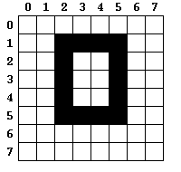
s.drawRectangle(4,3,10,5) | 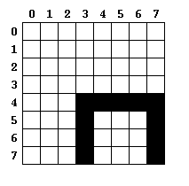
s.drawRectangle(4,4,8,9) | 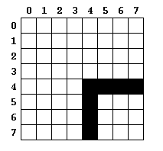

 | s.fillRectangle(3,4) | 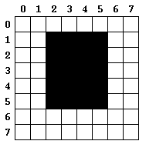
 | s.fillRectangle(6,6) | 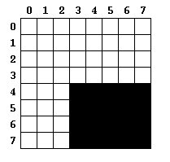
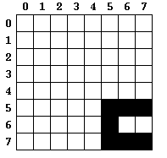 | s.fillRectangle(6,8)

